A Quiz on Basic Electrical & Electronics
A quiz on Basic Electrical and electronics was organized by the IEEE MVSR SB PES Student Chapter in collaboration with the IEEE MVSR SB WIE AG and which was supervised by Mrs. G. Ushasri, IEEE MVSR WIE AG Advisor, and Mr. Y. Laxmi Narsimha Rao, IEEE MVSR SC Advisor.
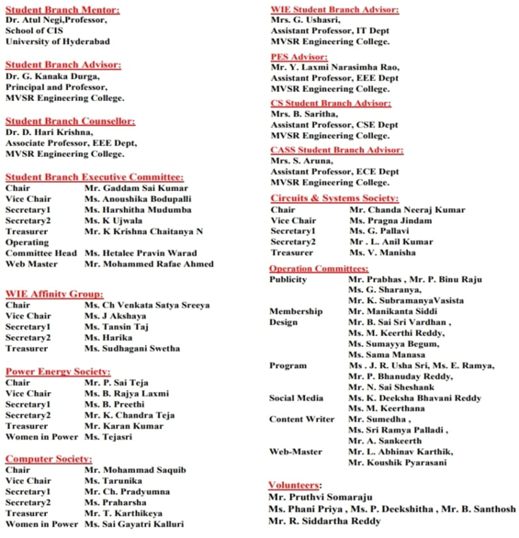

Session Details:
Date: 2nd December 2023
Timings: 5:00 p.m. to 6:30 p.m.
No. of Participants: 68
No of IEEE Members: 5; Non-IEEE members:63

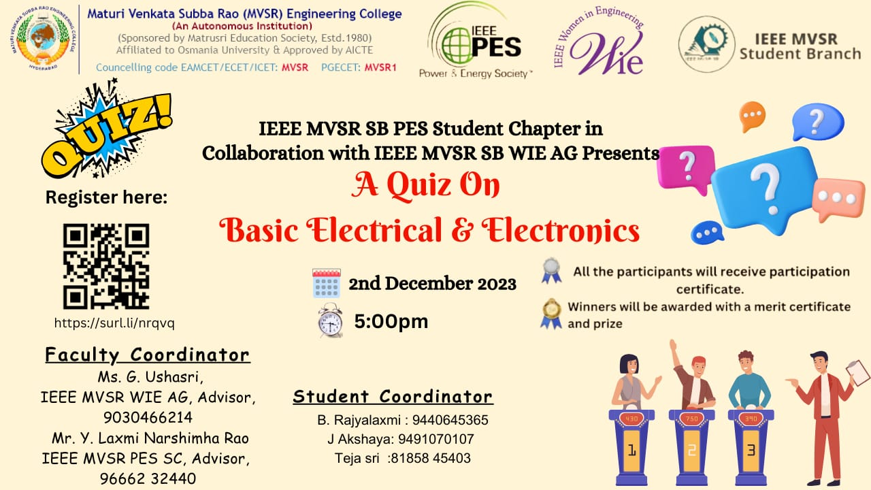
Poster of the Event

Ms. B. Rajyalaxmi, IEEE MVSR PES Student Branch Vice-Chairperson, began the event by welcoming all the participants and informing the students about the quiz instructions. Ms. J. Akshaya, IEEE MVSR WIE Student Branch Vice-Chairperson, addressed the gathering and discussed the awards and stated that winners would get a merit certificate and moreover, the first-place winner would get a year of free IEEE membership, while the second-place winner would receive 50% off a year's membership. She also mentioned that if the winners are already IEEE members, the award will be used to renew their membership.
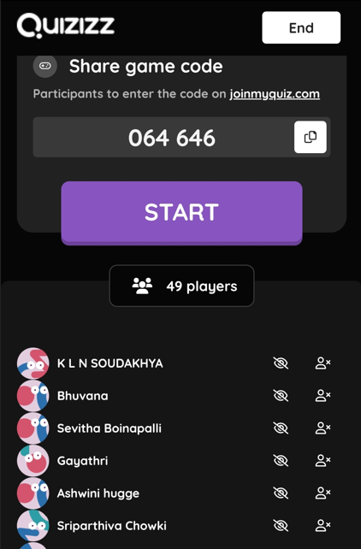
The online BEE Quiz being conducted on the “Quizizz” platform
The online BEE QUIZ conducted on QUIZIZZ platform was then launched by Ms. J. Akshaya and Ms. Teja Sri, IEEE MVSR PES Student Branch Women in Power, who shared the quiz link with all the students in Google Meet.
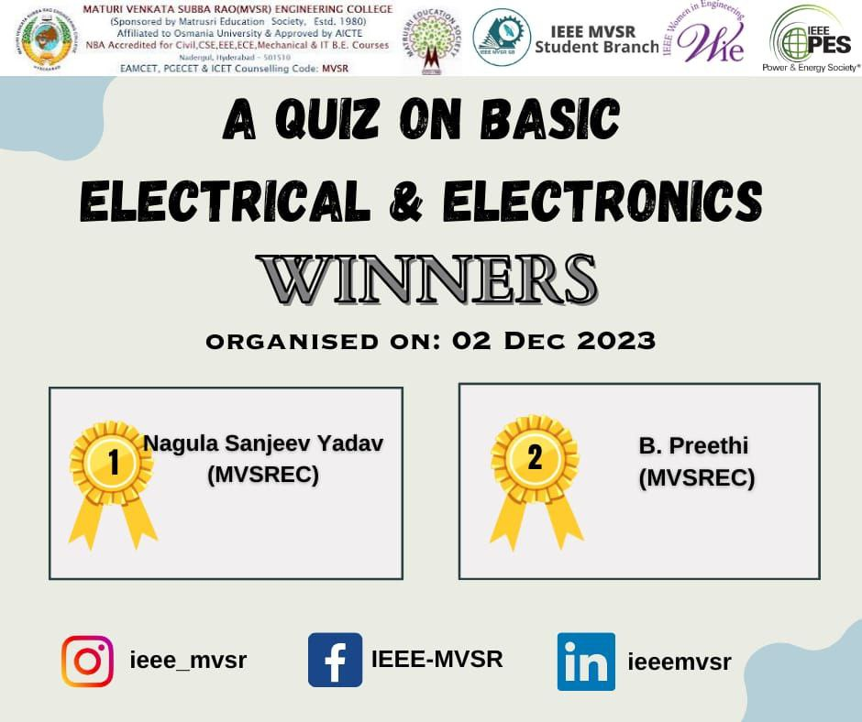
Winners of the Quiz

Lastly, Dr D. Harikrishna, IEEE MVSR SB Counsellor, announced the winners based on their Score, Accuracy, and Average Time. Mr. Nagula Sanjeev Yadav, EEE-A student, took first place, while Ms. Preethi, EEE-A student, took second place in the quiz. Mrs. G. Ushasri also expressed her congratulations to the winners of the competition. The quiz has been concluded with a vote of gratitude from Ms. J. Akshaya who expressed her gratitude to Mrs. G. Ushasri and Mr. Y. Laxmi Narsimha Rao for conducting the event, as well as all the students for their active participation

List of Participants:
S.no | Name of the Participant | Roll Number | IEEE ID
1 | Mohan Burgula | 2451-23-733-130 | 99702821
2 | K Ujwala | 2451-20-737-148 | 97508428
3 | Laxmigayathri Palla | 2451-21-734-058 | 98946841
4 | GARLAPATI AKHIL | 2451-21-735-010 | 99661967
5 | Aryan Karamtoth | 2451-23-737-009 | 99689785
6 | Poojitha | 2451-23-737-009 | NA
7 | Alenoor Sushrutha | 2451-22-733-069 | NA
8 | NAGULA SANJEEV | 2451-21-734-317 | NA
9 | SHAMSHUDDIN | 2451-22-735-144 | NA
10 | K L N SOUDAKHYA | 2451-23-735-156 | NA
11 | Godadevi Vangapally | 2451-22-737-011 | NA
12 | A.Saivivek | 2451-22-735-013 | NA
13 | A.Jhansi | 2451-21-737-184 | NA
14 | Bijjala Preethi | 2451-21-734-304 | NA
15 | Lingannagari Prajwala | 2451-22-737-165 | NA
16 | Kyasanipalle Gayathri | 2451-21-733-309 | Na
17 | Sevitha Boinapalli | 2451-23-735-155 | NA
18 | Merugu Akshaya | 2451-22-734-013 | NA
19 | VINDHYALA SNIKITHA | 2451-23-735-028 | NA
20 | ROUSHAN KUMAR | 2451-21-734-328 | NA
21 | Vijay Kiran Govindbaksh | 2451-21-734-321 | NA
22 | B Surya Kalyan | 2451-22-735-167 | NA
23 | Alluri.laya | 2451-21-734-316 | NA
24 | G Siddhartha | 2451-20-735-094 | NA
25 | THUMU SATVIKA | 2451-21-733-313 | NA
26 | B Dhruvaraj | 2451-22-734-302 | NA
27 | BATUVULA SRIKANYA | 2451-21-733-308 | NA
28 | KADAVERU SAIPAVAN | 2451-21-734-306 | NA
29 | GUNDÀ BINDUSREE | 2451-22-737-089 | NA
30 | GUNDA BINDUSREE | 2451-22-737-080 | NA
31 | V HARSHITHA | 2451-22-733-053 | NA
32 | GAVVA PAVAN KUMAR | 2451-21-734-314 | NA
33 | GUNDA BINDUSREE | 2451-22-737-089 | NA
34 | S.NAVYA SREE | 2451-22-734-032 | NA
35 | Burgula Mamatha | 2451-23-735-184 | NA
36 | Thambala Praneeth Kumar | 2451-22-735-077 | NA
37 | P.Satya Sai Shashank | 2451-22-735-031 | NA
38 | Sk.Abdul Ahad | 2451-22-737-083 | NA
39 | Mididoddi Spandana | 2451-21-733-092 | NA
40 | ZEYA UL MUSTAFA | 2451-20-734-072 | NA
41 | BITLA SRAVYA REDDY | 2451-22-737-006 | NA
42 | Shivani Ganji | 2451-23-735-124 | NA
43 | Bapatla Venkata saieesh | 2451-21-735-055 | NA
44 | TULA RAJDEEKSHITH | 2451-22-735-301 | NA
45 | Maripala.Shailaja | 2451-23-735-041 | NA
46 | Budidha Sindhu | 2451-22-737-172 | NA
47 | Chaitan Reddy | 2451-22-750-001 | NA
48 | K. Meenakshi | 2451-22-735-057 | NA
49 | M. Shiva Kumar Yadav | 2451-23-735-018 | NA
50 | Bajjuri naveen | 2451-23-733-141 | NA
51 | P VISHNUVARDHAN | 2451-22-734-301 | NA
52 | Mohammed Sohail Ahmed | 2451-22-737-082 | NA
53 | BUDIDHA SINDHU | 2451-22-737-172 | NA
54 | M. Shiva Kumar Yadav | 2451-23-735-018 | NA
55 | Yedla Likitha | 2451-22-737-121 | NA
56 | Ch Pavan Venkata Sai | 2451-23-735-171 | NA
57 | K lakshmi Nagaphani | 2451-23-735-156 | NA
58 | Mamidala Harsha Vardhan | 2451-22-735-012 | NA
59 | Thanooj Achini | 2451-22-734-026 | NA
60 | R. Rohini | 2451-22-735-112 | NA
61 | Saksham Thakur | 2451-22-735-069 | NA
62 | B.SAI KOWSHIK | 2451-21-735-301 | NA
63 | SYED AZAM ALI | 2451-23-735-058 | NA
64 | V.Preethi Reddy | 2451-22-733-098 | NA
65 | Velimineti Sai Sushanth | 2451-20-733-169 | NA
66 | SHEELAM DEEPIKA | 2451-23-737-036 | NA
67 | POTHUGANTI SHRAVYA | 2451-23-735-019 | Na
68 | G.Sathwik | 2451-22-735-101 | NA

Reported by:
IEEE MVSR SB

